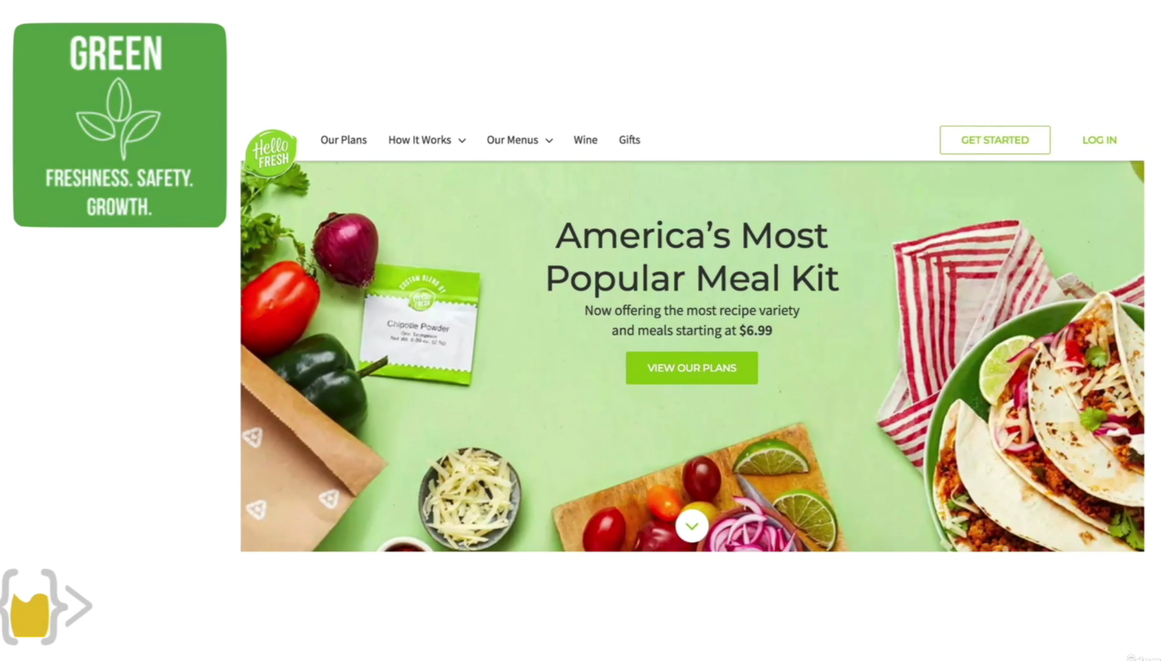

Hace que haga pop --------- resalta

